2017-2018 Paul R. Manske Award Winning Papers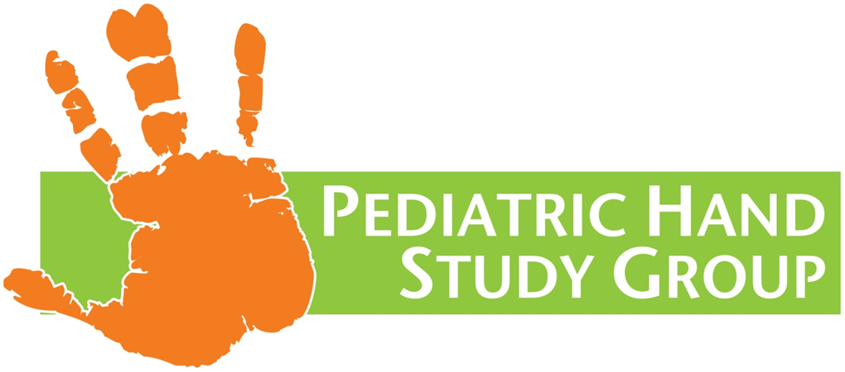
- 2017 – Treatment of congenital collapsed thumb in arthrogryposis
The Journal of Hand Surgery (European Volume), 2017, Vol 42E(8) 794-798
H. Abdel-Ghani, M. Mahmoud, A. Shaheen and M. Abdel-Wahed
- 2018 – Functional Impact of Congenital Hand Differences: Early Results from Congenital Upper Limb Differences (CoULD Registry)
J Hand Surg Am. 2018 April Vol 43 (4): 321-330.
Donald S. Bae, MD, Maria F. Canizares, MD, Patricia E. Miller, MS, Peter M. Waters, MD, Charles A. Goldfarb, MD

